Hello,

I am trying to add leaders to our tiger den. When I do so it keeps saying Position #1 already exists when I try to add Chris Pecone as a den leader and Jessica Pecone as the assistant den leader and I get the same message.

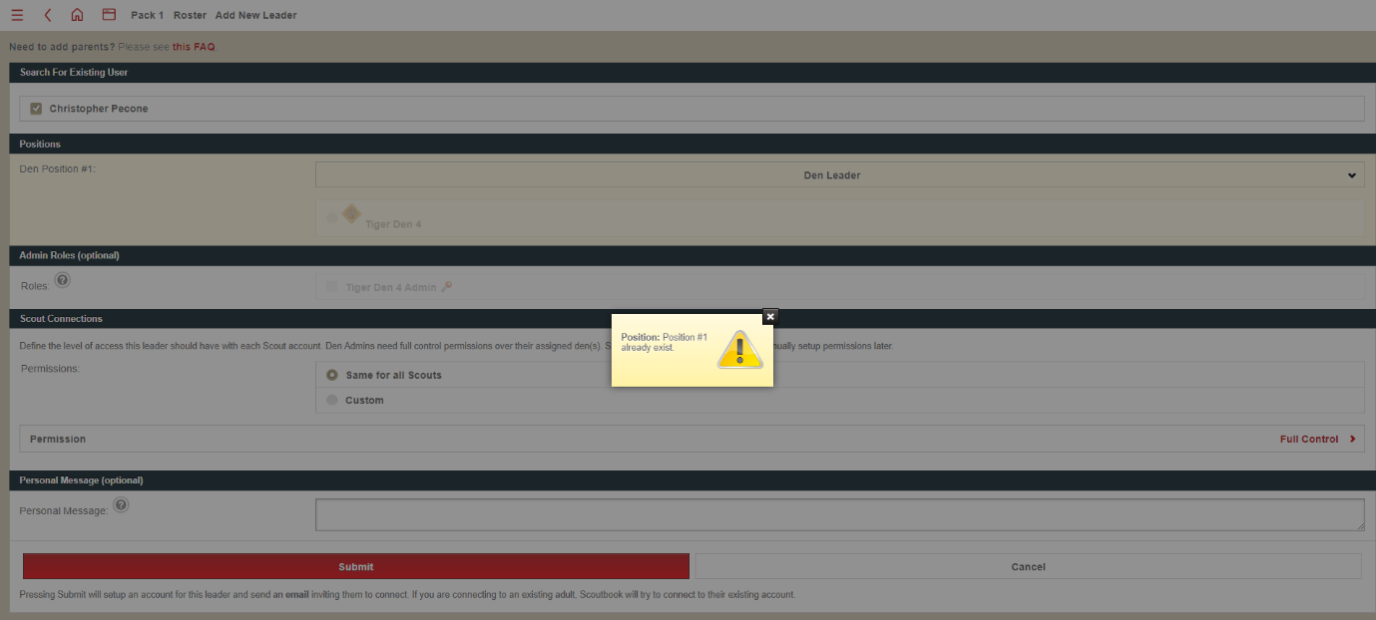

I have tried to add myself as a cubmaster i get this message

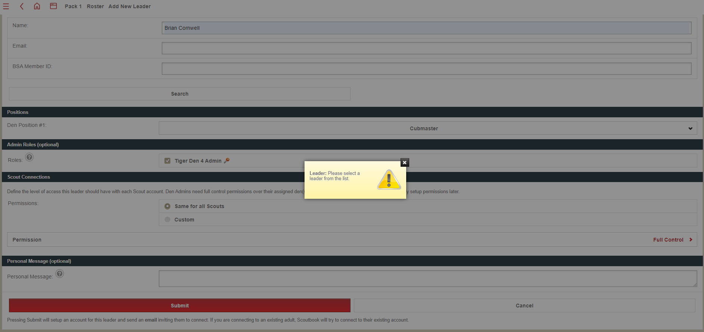

When I go to the den it does not show a leader assigned.

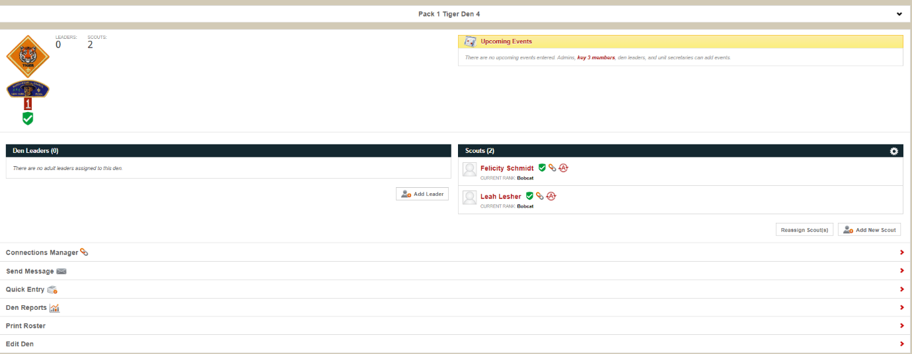

I have tried to start an entirely new den (den 6) thinking that if it would work, I would just transfer the girls to the new den, and it does the same thing as den 4. Can someone please assist me with this issue?