Alternatives:
- When at the My.Scouting log-in page click on the CHATBOT (the square balloon icon in the blue circle at the bottom right hand corner on the web version). Then type “Training History” You will then be asked for a Member ID and last name combination. This will give you a listing on screen of about 10 trainings (not necessarily the ones you are looking for) PLUS a link “And xx more…” hyperlink (if there are more) at the bottom it will push you to a new My.Scouting window. Once you log in, a “My Training” window will open listing all your training.
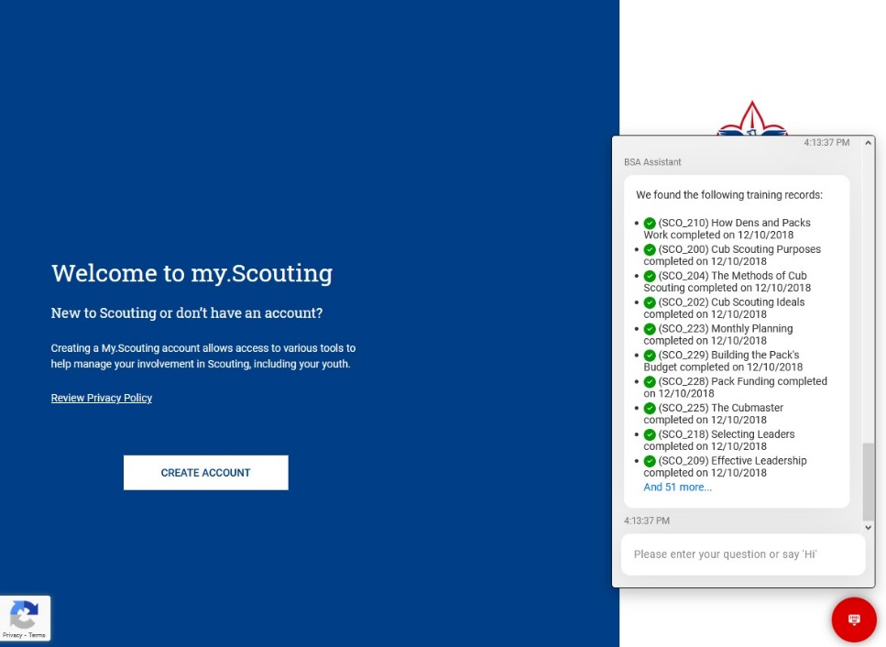
- Alternatively, you could use Training Manager, navigate to the organization (unit or district) the individual(s) are in, click on the Add/Search left-hand option, click on the “Search” tab, select the individual(s) and then either ‘View Training’ or ‘Download Training Report.’

* Notes:
- The downloaded individual ‘Training Report’ is actually NOT the full report training report for the individual (instead it is a “Position Training Requirements Report” to be considered trained for the selected organizational position(s)). I am working with BSA IT to provide both this report (Position Training Requirements Report) and the actual full Training Report here, BUT you can get the FULL listing of Leader Training Completed (see Note 2).
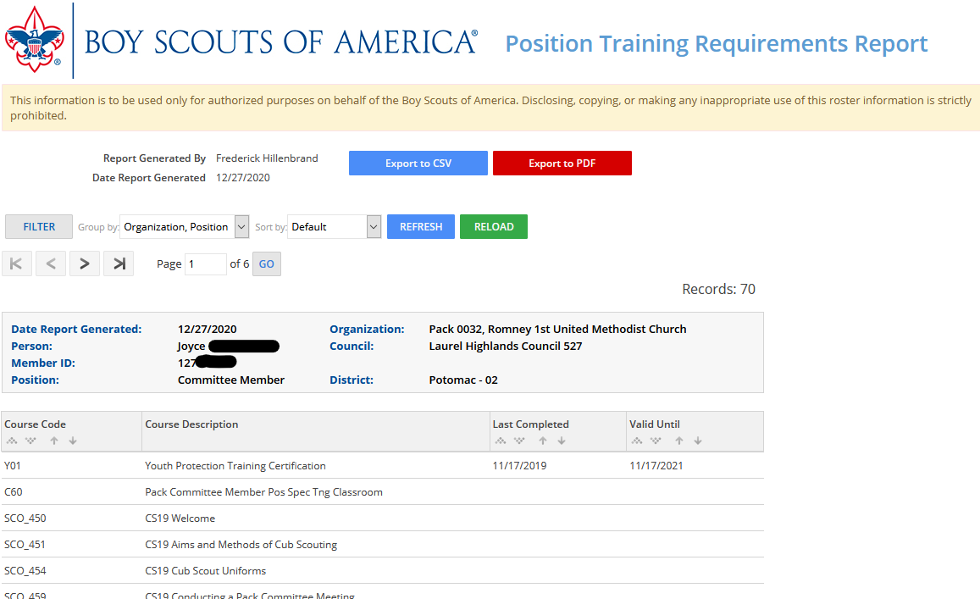
- If you VIEW the Training, you can see all the individual’s training if you change the filter. From this screen you can also select and download completion certificates.
You can also download the individual’s FULL listing of ‘Leader Training Completed’ if from the ‘View Training’ screen you click the “Training Report” download icon.
